Terms Need to Understand:
RPO refers to the maximum acceptable amount of data loss an application can undergo before causing measurable harm to the business
RTO (Recovery time object) states how much downtime an application experiences before there is a measurable business loss
CLR common language runtime
CLI Azure Command line interphase
IOPS Input/output operations per second
Latency is the delay between a user's action and a web application's response to that action
BCP Bulk copy program
RBAC Role base access control
TLS Transport Layer Security
TDE Transparent Data Encryption
CEK Column Encryption Key
CMK Column Master Key
RA Read Access
RO Read Only
GES geo redundant storage

P Local storage
S Secondary storage
R Remote storage

AZURE SQL:
Different types of deployment:
- IAAS
- PAAS(Managed instance)
- PAAS (Azure SQL Database)
IAAS:
- Just a SQL server running on AZURE VM’s
- AZURE will manage infrastructure and hosting
- User will manage OS and SQL server
- Problem Statement :
  - There hardware solution must expire
  - Need to move cloud as must as possible with out big changes
  - Need 3rd party access with AZURE even
  - Having SQL server 2008 or older
- Key Points:
  - lift and shift model where local database is connected with cloud
  - VM's can automatic backup data as blob
  - Auto update from 2008 SQL
  - Using Azure site recovery its easy to migrate to VM’s
  - Memory and storage can be optimised
  - Temp DB for SSD
  - Ultra-desks for very low ureses

PASS (MI):
- AZURE SQL Server (MI)
- AZURE will manage infrastructure, hosting and OS
- User will manage SQL server
- Problem Statement :
  - They want to migrate to azure cloud to remove management but need instance scope features like SQL Agents, service Brokers , CLR
- Solution:
  - SQL MI is a combined module build for SQL servers for premises customer
- Key Points:
  - Fully managed instance
  - SQL server surface
  - Supports VM’s
  - Zero downtime
  - Will have all IAAS + PAAS benefit
  - we can use A-AD login or A-WA in
  - For creating: 4 hr
  - For Updating: 2.2 hr
  - For Deleting: 1.2 hr

PAAS (SQL Database)
- AZURE SQL Database
- AZURE will manage infrastructure, hosting, OS and Server
- User will manage database
- Problem Statement :
  - We want to build a modern apps , with less downtime and more high availability and performance
  - Need to develop multi-tenant solutions
  - Need to pay for what they use
- Solution
  - SQL Database is a highly scalable cloud service build with ML solution
- Key Points:
  - Fully managed instance
  - SQL server surface
  - Hyper scale (100 TB+)
  - Private link support
  - High availability
  - Single and elastic pools
  - Single (used for application which need only one data base)
  - Elastic (multi databases but common memory and CPU) is used for Unstable DTU counts when used for many data bases then cost will be less when compared to single model
  - 5 sec ROP and 30 sec RTO (better than AWS)
  - 99.995% availability

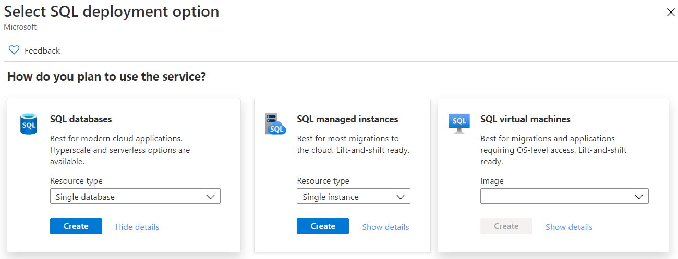

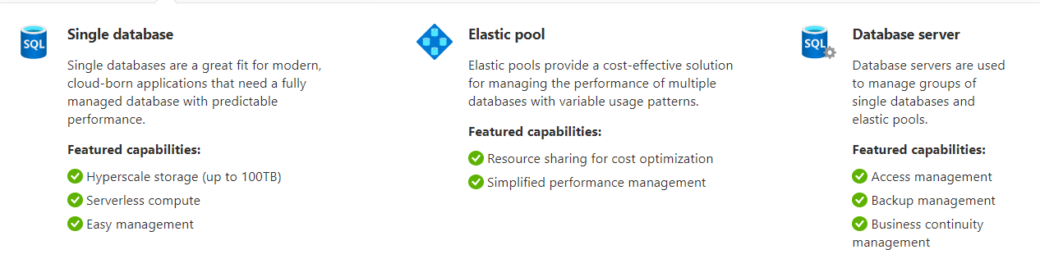

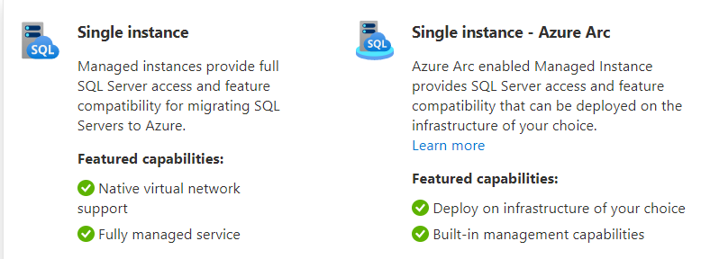

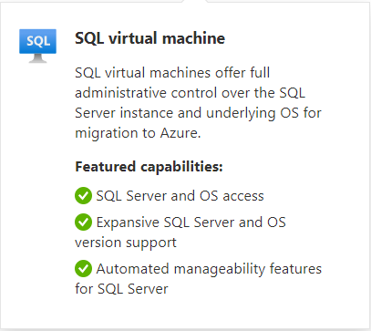
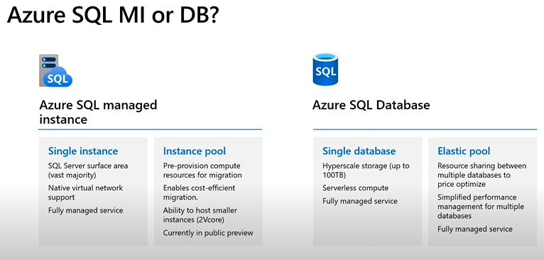

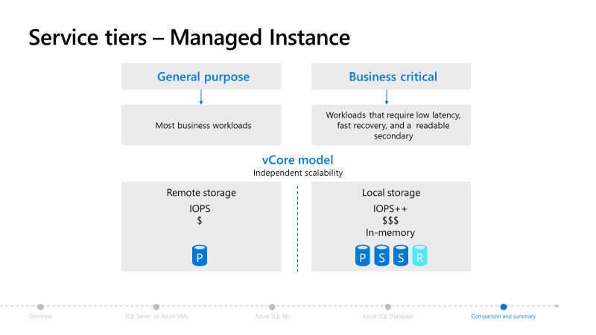
  - General Purpose (Low end) (8TB Blob data, HDD only)
  - Business Critical (High end) (HDD+ SSD, read only databases are allowed, Gen4 and Gen5 Tech also allowed)

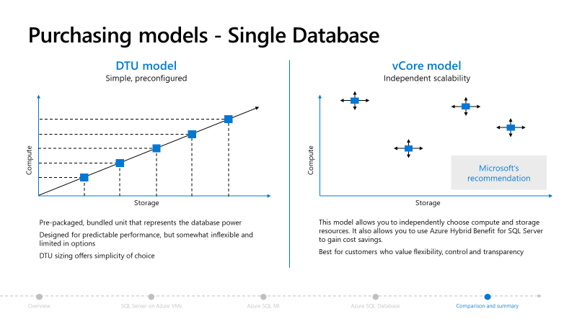
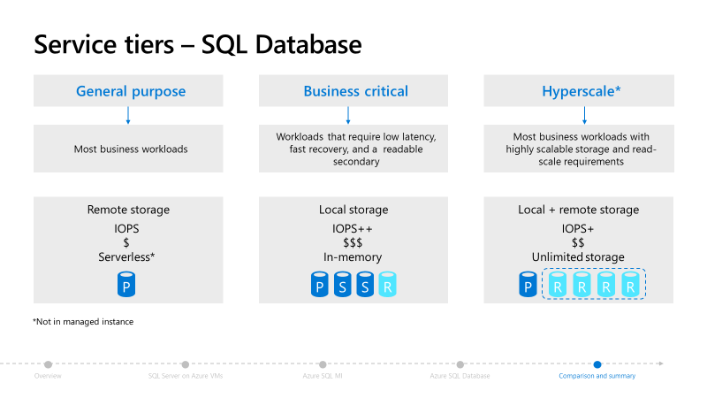
Data Base Pricing Models:
- DTU
  - basic
  - standard
  - premium
    - User cannot change CPU, Memory, Storage amounts
    - Supports only single and elastic pool
    - Need to use DTU Cal to Cal amount and then need select the range supports for us
    - right now, we are not allowed to change from DTU to Vcore
    - if u use more than 300 DTU then V core is nice option
    - can use AZURE CLI to convert from DPU --> V core
- Vcore
  - General Purpose
  - Hyper Scale
  - Business Model
    - full flexibility can manage any thing
    - supports all types of models
    - for on promises system changed to cloud then know how much they use so they can configure easily
    - allows u use server less option in Database (as per our utilization Azure bots only automate our resources results reduce off cost)
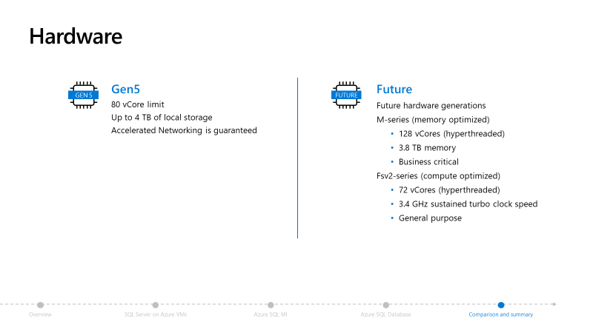

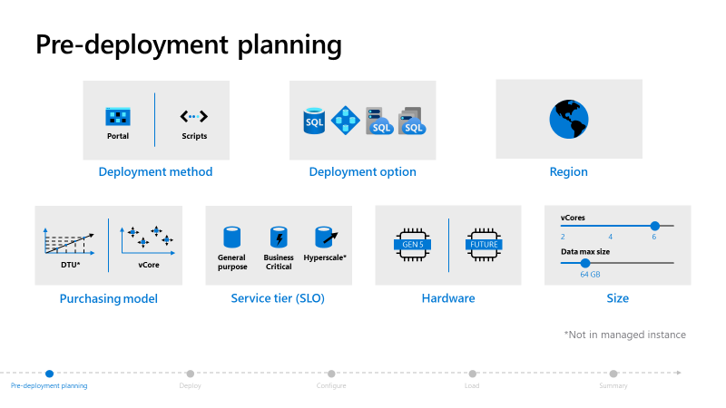
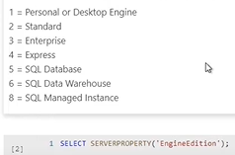

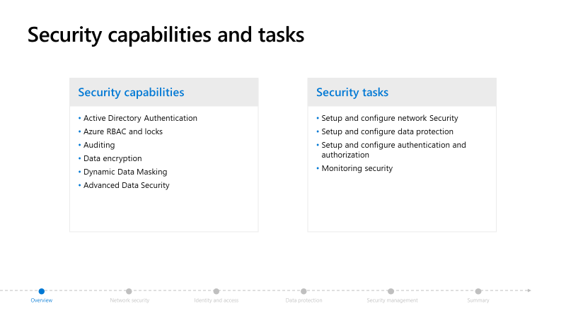

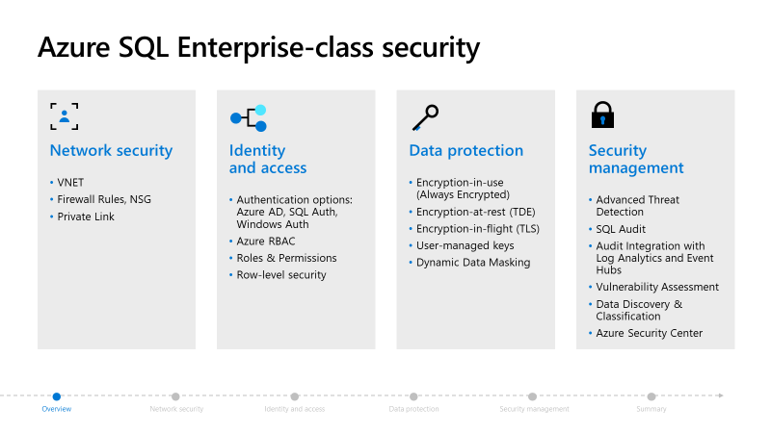

Dynamic Data Masking:
- Allows users to view secure data without viewing the entire value (Email: xxxxharxx@gmail.com)
- Dynamic Data Masking is a presentation layer feature
- unmasked data will always be seen by administrators
- Dynamic Data Masking supports a variety of masking patterns
  - default masking option fully masks the data (xxxxxxx)
  - Credit Card masking option masks all but the final four characters allowing users to view (XXXX-XXXX-XXXX-1234)
  - Social Security Number option masks all expect the final four characters (XXX-XX-1234)
  - Random Number masking option
  - Custom Text masking option allows you to specify any rules that are needed.
  - Email
  - Salary
- Don’t use as primary security measure
- There will be no change in Transport layer
- Encryption is different from Data Masking
- Select query’s will provide end result with original data in where condition
- Views and Select statements will also show only masked data
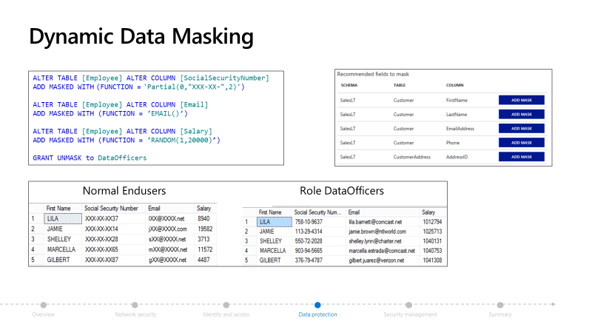
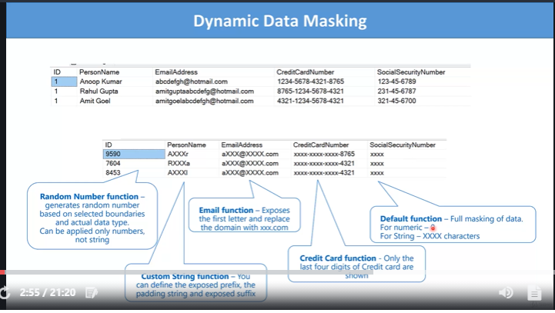
Data Encryption (Azure level):
Data States:
- Rest (Stored in DB)
- Motion (Moving inside Azure or out side Azure)
- Processing or Use (Updating or deleting some sort of querying)
Types of Encryption (Approach):
- Symmetric
  - Data encrypted and decrypted with public key
  - Simple Operation
  - Low Cost and Low Secure
- Asymmetric
  - Data encrypted with public key decrypted with private key
  - Complex operation
  - High Cost and High Secure
Types of Encryption (Data Processing)
- Deterministic encryption
  - It will all ways generate same encrypted value for same plain text
  - We can perform Grouping , indexing, looking up
- Randomized encryption
  - It will all ways generate different encrypted value for same plain text
  - Very hard to guess and crack
  - Grouping , indexing, looking up can not be applied

Encryption in Rest:
- By default encrypted 256 bits AEC
- We can On or Off encryption at DB level
- We can use MS generated key or Custom generated key for encryption in SERVER, DATA WARE HOUSE, STORAGE Accounts
- We cannot change encryption for COSMOS DB

Back Ups:
- Full Backup
  - Backups whole database
  - Backups for every 7 Days (week)
- Differential Backup
  - Captures only the data that has been changes from your last full backup
  - For every 12 hours
- Transaction Log Backup
  - Records all commented and uncommented truncations
  - For every 5 to 10 min
- Backup files are copied to RA-GRS (primary storage)
- RO GRS (secondary storage)
- All these backups are encrypted in Rest and motion in blob storage

Backup retention Types:
- Point in time restoration (PITR) 7 to 53 days
- Long team restoration (LTR) up to 10 Years
  - Not applied for Managed instance
  - For ML use SQL Agents
  - Will store Full database backup for every week upto 10 years
Note: backups are taken at database level but need to configure at server level

